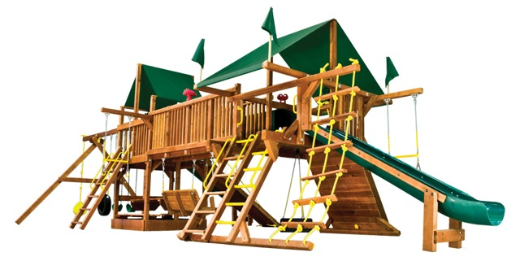

Playground Rules

Please note there is no parking allowed at or in front of the playground area. This is to eliminate congestion in front of the playground for the safety of the kids and to allow homeowners who live close to the playground access to their homes.

* Playground reserved for use by Raintree HOA members only
* Use playground at own risk
* All children under 9 must be accompanied by an adult at all times
* Playground hours are from 9 am to dusk
* No pushing, shoving, or fighting
* No glass containers or alcoholic beverages allowed
* Pick up your trash
* Do not use equipment when wet
* Swings
  + Hold on with both hands
  + No standing
  + No jumping off swings
  + Stand clear of moving swing
* Slide
  + Slide feet first
  + No running or climbing up slide